EVENT MANAGEMENT SYSTEM
(13 size) A Project Based Learning Report Submitted in partial fulfilment of the requirements for the award of the degree

of

Bachelor of Technology
in The Department of Computer Science Engineering
24AD2103A - DBMS

Submitted by
2410030138 K.Gowtham
2410030188 Anish Jadhav
2410030320 V.Mukesh
2410030496 Polepally Karthikeyan
2410030250 Kishore Reddy

Under the guidance of
Dr.Rama Rao
Associate Professor


Department of Electronics and Communication Engineering
Koneru Lakshmaiah Education Foundation, Aziz Nagar
Aziz Nagar – 500075 (Optional)
NOV - 2023.
Abstract

The Event Management System is a comprehensive database project developed to automate and simplify the process of organizing, managing, and monitoring various events in an efficient and systematic manner. In today’s digital world, managing events such as seminars, conferences, cultural programs, workshops, and meetings requires the handling of large amounts of data related to participants, venues, schedules, resources, and payments. Performing these operations manually is time-consuming, error-prone, and lacks real-time accessibility. To overcome these challenges, the proposed Event Management System provides an integrated database solution that centralizes event-related data and ensures accurate, secure, and efficient management.
This project primarily focuses on implementing database management system (DBMS) concepts to design a structured and relational data model that supports event operations. The system stores all information in a relational database and maintains relationships between entities such as events, users, organizers, participants, venues, and resources. The design follows normalization principles to reduce redundancy and improve data consistency. By applying constraints such as primary keys, foreign keys, and referential integrity rules, the system ensures reliable and accurate data storage. SQL queries are used to perform operations like insertion, deletion, updating, and retrieval of event data, thereby providing flexibility and control to administrators and users.
The main objective of the Event Management System is to create a platform that allows administrators to manage events efficiently from a single interface. It supports functionalities such as creating new events, registering participants, assigning venues, tracking attendance, and generating event reports. Organizers can also view event schedules, manage available resources, and monitor participation statistics. The system provides role-based access control, ensuring that only authorized users can perform sensitive operations, thereby maintaining data security and privacy. Technologies such as MySQL, PostgreSQL, or Oracle Database can be used for data management, while front-end tools like HTML, PHP, Java, or Python (Flask/Django) can be employed to build the application interface. This structure ensures modularity, scalability, and ease of maintenance.
From a functional perspective, the Event Management System offers features like event registration, venue booking, participant management, and feedback collection. It also generates reports that provide insights into event performance and participation levels. These reports help in decision-making and future event planning. Additionally, the system enforces data integrity and confidentiality through authentication mechanisms, data validation, and secure database connections.
The advantages of this system include automation of manual processes, reduced human errors, enhanced coordination, and improved accessibility of event-related information. It ensures faster data retrieval, better communication between organizers and participants, and efficient allocation of resources. Moreover, the system supports scalability, allowing new functionalities to be added easily as the requirements evolve.
In conclusion, the Event Management System serves as an efficient, secure, and reliable solution for managing events of any scale. By integrating database management principles with event operations, the system enhances productivity and simplifies complex management tasks. It is an ideal project for understanding the practical implementation of database concepts such as normalization, relationships, constraints, and SQL operations. This project not only demonstrates the real-world application of DBMS but also provides a strong foundation for future enhancements like online payment integration, automated notifications, and data analytics for event performance evaluation.

List of Figures
(if any)
ER MODEL:
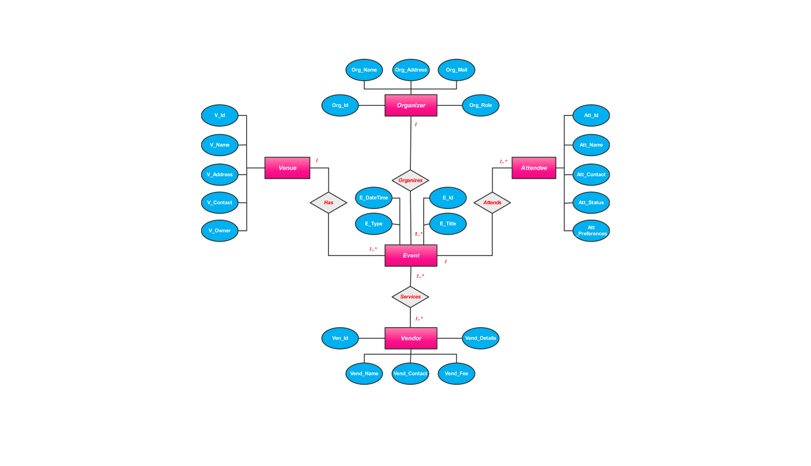
USE CASE MODEL:
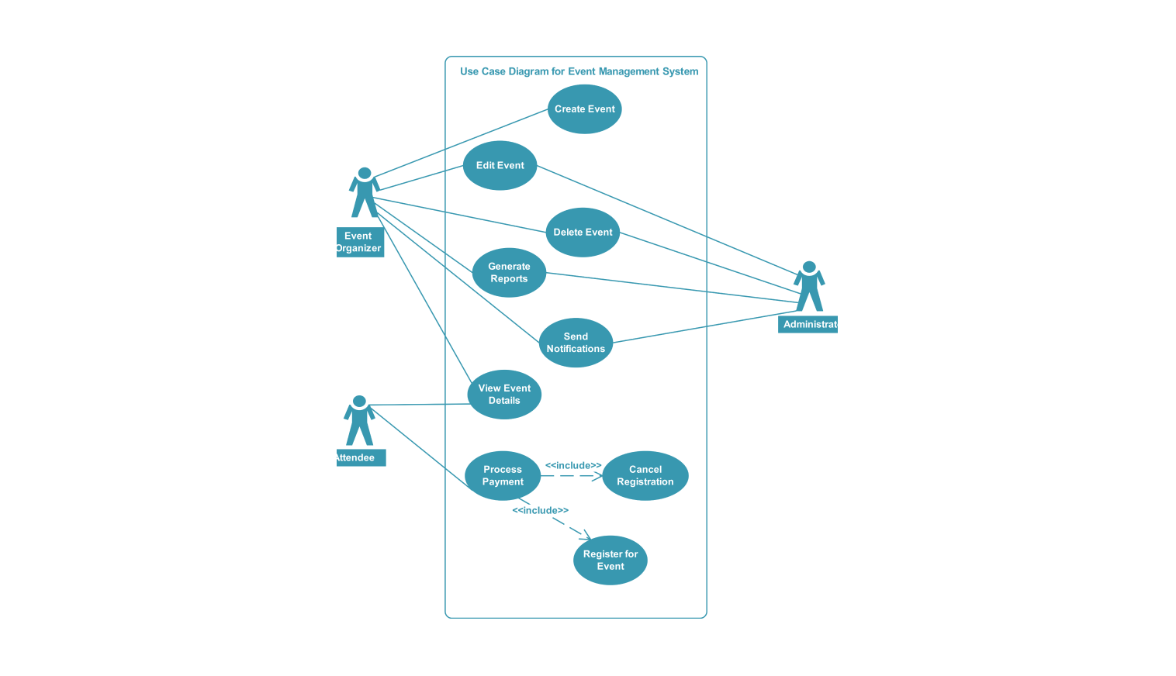

List of Tables

(if any)

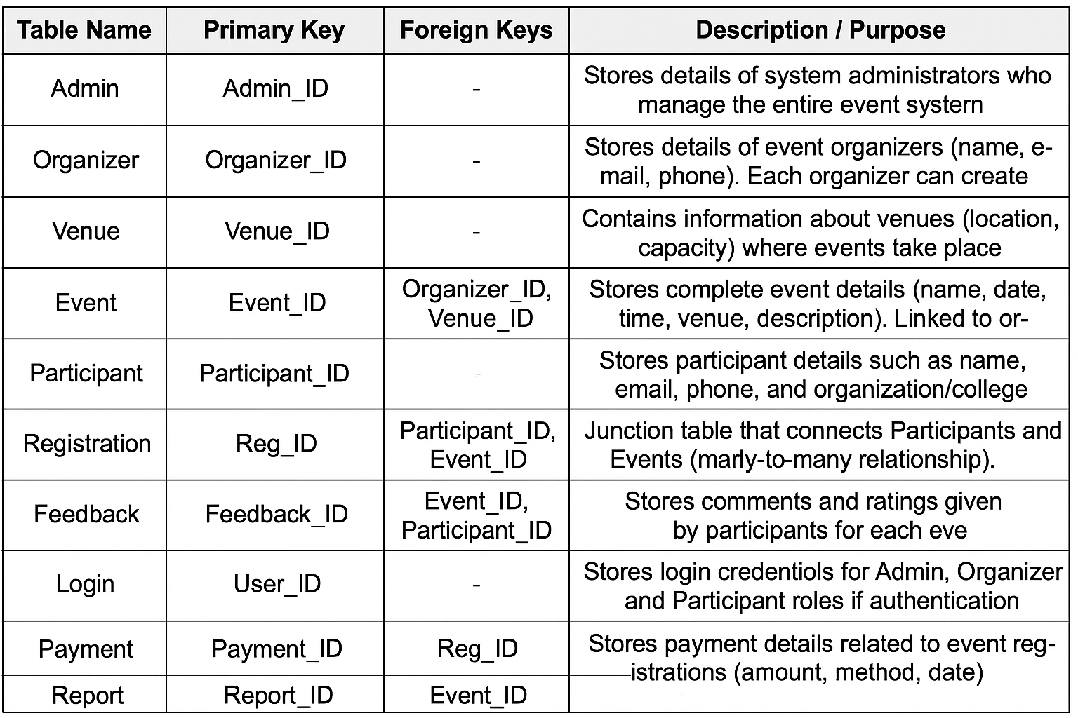
Table of Contents

1. Introduction
In today’s fast-paced world, organizing events requires meticulous planning and coordination. From workshops and conferences to college events and social gatherings, managing events manually can be time-consuming and prone to errors. Event organizers need tools to create events, manage registrations, track attendance, and communicate updates efficiently.
To address these challenges, we developed the Event Management System, an online platform where users can easily create, manage, and participate in events. The main goal is to centralize event management in one platform, providing features for registration, notifications, attendance tracking, and event discovery. Users can search events by categories, tags, or dates, and organizers can monitor registrations, communicate with participants, and receive feedback.
This system stands out due to its user-friendly design and accessibility across devices. Event details such as date, time, location, capacity, and participant information are organized efficiently to save time and reduce errors. Additionally, the platform encourages community engagement by allowing users to share events and provide ratings or feedback.
Overall, the Event Management System simplifies event planning, reduces administrative workload, and enhances participant experience, making it an essential tool for modern event management.

2. Methodology

To develop an effective Event Management System, we followed a systematic development approach focused on usability and functionality. First, we analyzed existing event management platforms to identify key features such as event creation, registration, notifications, participant management, and search functionality.
Our design principle was simplicity. We implemented an intuitive interface with clear navigation, searchable event listings, category filters, and calendar views. Organizers can create events with details like name, date, location, capacity, and description. Participants can register, receive notifications, and track upcoming events.
Community features such as event feedback and sharing were incorporated to enhance engagement. Backend structures were designed for future integration with databases to store event data, track participation, and manage user accounts.
By following this methodology, the system combines robust technological foundations with practical usability, ensuring effective event planning and management.

3. Experiments
The experimentation phase focused on evaluating the system’s core functionalities and user experience.
Functionality Testing:
Sample events such as workshops, webinars, and college competitions were created by test users. Each event was categorized, tagged, and made searchable to test creation, browsing, and registration functionality. Event notifications and participant tracking features were also tested.
Usability Testing:
A group of 15 participants, including students and organizers, tested actions like event creation, registration, filtering, and feedback submission. Feedback was collected on ease of use, speed, and overall satisfaction.
Performance Testing:
System performance was evaluated under concurrent users browsing, registering, and creating events. Response times, database queries, and load handling were measured to ensure stability and responsiveness.
The experiments confirmed that the platform effectively handles multiple events, users, and real-time interactions, making it practical for real-world use.

4. Results
Working Prototype: A fully functional front-end prototype demonstrating event creation, registration, category filtering, notifications, and feedback submission.
Usability: Test users found it easy to create, search, and register for events.
Responsiveness: Layout adapts seamlessly across desktop and mobile devices.
Extensibility: The structure allows backend integration for user accounts, event databases, and analytics without major front-end changes.

5. Conclusion
The Event Management System provides a practical, efficient, and user-friendly platform to manage events. It saves time, reduces administrative effort, and enhances participant experience. Organizers can create and manage events efficiently, while participants can easily discover, register, and interact with events.

Future Work:
Backend Integration: Add a server and database (Node.js + MongoDB or Firebase) to store events, user accounts, and participant data.
Authentication: Enable user login, registration, and personal dashboards.
Notifications: Implement real-time notifications for upcoming events or updates.
Advanced Search: Include filters for date, category, popularity, and location.
Analytics: Track event participation, feedback, and trends.
Mobile App or PWA: Develop a Progressive Web App or native app for offline access and notifications.
Collaborative Features: Enable comments, ratings, and community curation for events

References

GeeksforGeeks — https://www.geeksforgeeks.org/
W3Schools — https://www.w3schools.com/
Eventbrite — https://www.eventbrite.com/

